**Phylogenetic trees practice questions**

**BIOL121 UBC**

**Question 1**

Consider the phylogenetic tree shown below (from Freeman et al., 2011).

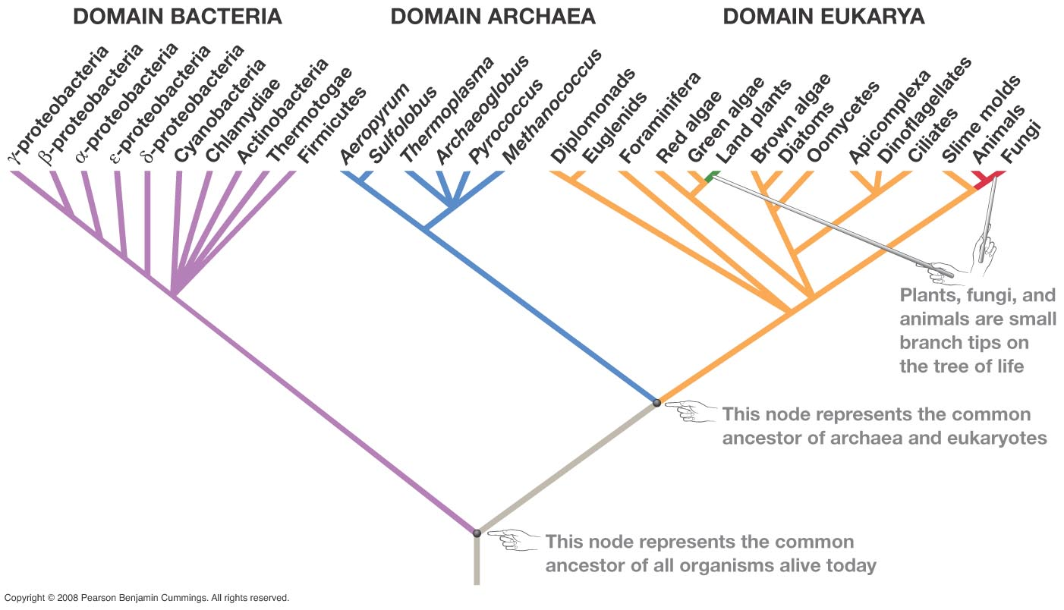

1. Is the group composed of the clade “Fungi” and the clade “Slime molds” monophyletic? Justify your answer. (2 marks)
2. Identify the smallest monophyletic group that includes red algae and green algae. List all of the members of this group.
3. On the tree, identify and circle the most recent common ancestor of land plants and animals.
4. Is it accurate to say that cyanobacteria are more ancient than fungi? Briefly explain your reasoning. (2 marks)
5. What is/are the closest relative(s) to Oomycetes. Briefly explain your reasoning (2 marks)
6. A lot of basic research in molecular and cell biology is performed on yeast (a fungus), and the results are typically well applicable to mammalian cells. Given how easy and inexpensive it is to culture it, yeast has become one of the most widely used model systems.

Bacteria such as *E. coli* are even cheaper and easier to culture, and their biology is extremely well known (*E. coli* is the organism that we know the most about in the whole world). Still, yeast is a much better model organism for studying cellular processes that occur in human cells. What is a likely reason for this?

**Question 2**

The tree below shows a phylogeny of animals and was built based on DNA sequences (from Freeman et al., 2011).

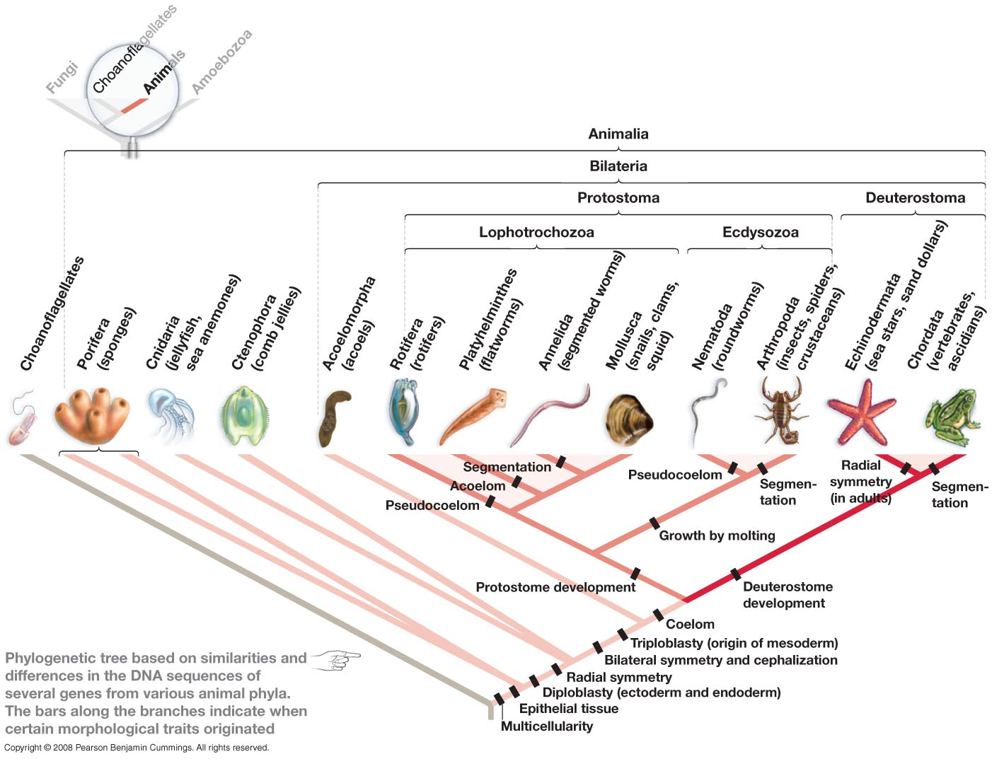

1. Is the group “Deuterostomata” (the deuterostomes) monophyletic? Explain your answer.
2. Do cnidarians and ctenophoras form a monophyletic group? Explain your answer.
3. Based on the tree above, what characteristics are common to all protostomes and deuterostomes?
4. Did the most recent common ancestor of all animals with bilateral symmetry (bilateria) most likely have a coelom or not? What characteristics did this ancestor probably have?
5. Why were choanoflagellates used as an outgroup?
6. How many monophyletic groups (without counting the tips of the branches) are present in the tree?
7. On the tree, identify and circle the most ancient organism that had ectoderm, mesoderm and endoderm.

**Question 3**

Which of the trees represented below show the same phylogenetic relationships as each other? Briefly justify your answer.

**B**

C.

A.

B.

D.

E.

**A**

**C**

**D**

**B**

**A**

**C**

**D**

**B**

**A**

**C**

**D**

**B**

**A**

**C**

**D**

**B**

**A**

**C**

**D**

**Question 4**

The figure below shows the phylogenetic relationship among various plant and green algae taxa. Each of these groups contains a large number of species. Nodes are labeled with letters. **(11 marks total)**

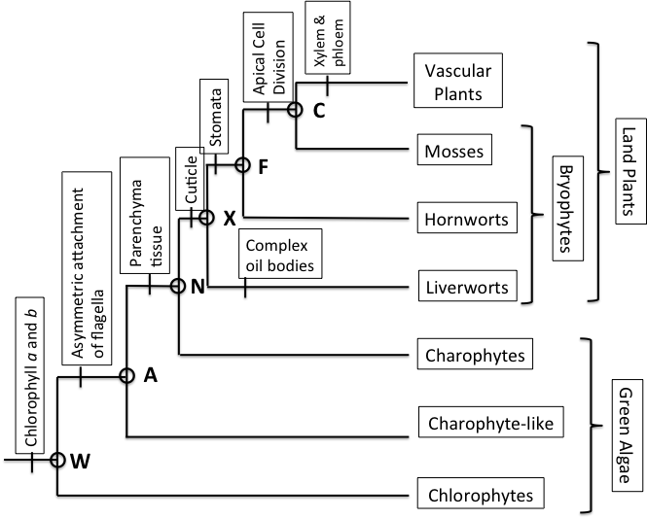

a) Are Charophytes descended from Charophyte-like algae? Briefly justify your answer. (**2 marks**)

b) List all of the taxa (at the branch tips) that are most closely related to hornworts. (**2 marks**)

c) Are land plants a monophyletic group? Briefly explain why or why not? (**2 marks**)

d) For which taxa would the trait of a cuticle be homologous? (**1 mark**)

e) Why would the trait of stomates be considered homologous in the taxa you have listed? (**2 marks**)

f) Vascular plants and bacteria are distantly related. However it is possible to engineer vascular plants with a bacterial gene and the gene produces a functional product which can affect the plant’s phenotype. Briefly explain how this is possible. (**2 marks**).

**Question 5**

The phylogeny shown in the figure on the next page is a hypothesis for the relationship among fungi and *Microsporidia*. Nodes are labeled with numbers shown above each of the nodes (1-11). Branches are labeled with letters below each branch (A-W).

i) How many times have flagella have been lost in fungi given this phylogeny. Flagella are extremely complex structures, so it is reasonable to assume that flagella can only be lost and not gained. (**2 marks)**

ii) Did the ancestor of fungi have a flagellum. Briefly explain your reasoning. (**2 marks**)

iii) On the phylogeny, indicate where flagella have been lost. Justify your answer with specific references to the presence or absence of flagella in specific ancestors and descendants (**5 marks**)



**Question 6**

The figure below shows the phylogenetic relationship among plants belonging to the Rosids. Some plants are parasitic on other plants they live by taking water and nutrients from a photosynthetic host plant. Most of these parasitic groups have completely lost the ability to photosynthesize. The plant groups indicated with a “\*” are parasitic. Plant groups lacking a star are not parasitic.

1. Given this phylogeny, how many times has parasitism evolved in the Rosids? (**1 mark**)
2. On the phylogeny indicate where parasitism has evolved (**2 marks for all correct; -0.5 marks for each incorrect answer**).
3. Was the ancestor of the Rosids parasitic? Briefly explain your reasoning. (**2 marks**)

****

**Question 7**

The phylogeny shown in the figure below shows hypothesized relationships among lineages of *Arcellinida* (shelled amoebae). This phylogeny is based on DNA sequence data. Nodes are labeled with numbers (1–11) above each node. *Arcellinida* amoebae shells are either made out of silica (glass), agglutinated (sand and particles glued together), or are organic (made of protein). The ancestor of the shelled amoebae clade had organic shells.

a) Applying the principle of maximum parsimony, how many times have agglutinated shells been gained based on this phylogeny?

b) Indicate on the phylogeny using only the letter “G” where agglutinated shells has been gained.

c) How many times have agglutinated shells been lost based on this phylogeny?

Amoebae_phylogeny_image